Лабораторная робота №

BigInteger

Паршин Олександр

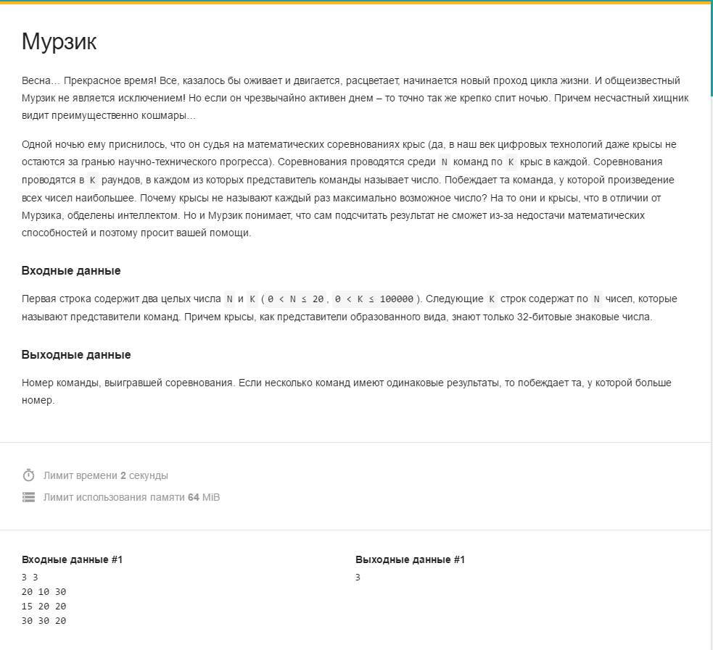

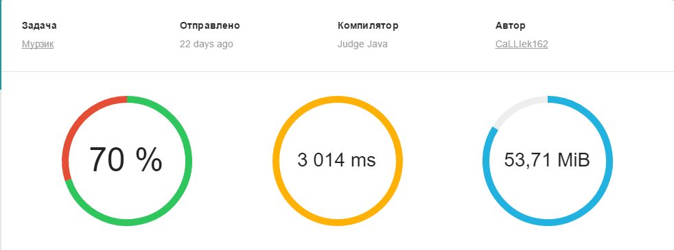

**import** java.io.Console;

**import** java.math.BigDecimal;

**import** java.math.BigInteger;

**import** java.util.Scanner;

;

*/\*\**

*\**

*\* @author parsh*

*\*/*

**public** **class** Main {

*/\*\**

*\* @param args the command line arguments*

*\*/*

**public** **static** **void** main(String[] args) {

*//* ***TODO*** *code application logic here*

Scanner cin = **new** Scanner(System.in);

**int** n = cin.nextInt();

**int** k = cin.nextInt();

BigInteger[] a = **new** BigInteger[n];

**for**(**int** i=0; i<n; i++)

{

a[i] = BigInteger.ONE;

}

**for**(**int** i=0; i<k; i++)

{

**for**(**int** j=0; j<n; j++)

{

**if**(a[j].**compareTo**(BigInteger.ZERO)!=0)

a[j]=a[j].**multiply**(**new** BigInteger(cin.**next**()));

**else**

cin.**next**();

}

}

**int** clan = 0;

BigInteger max = a[0];

**for**(**int** i=1; i<n; i++)

{

**if**(max.**compareTo**(a[i])==-1)

{

max=a[i];

clan=i;

}

**if**(max.**compareTo**(a[i])==0)

{

clan=i;

}

}

System.out.**print**(clan+1);

}

}

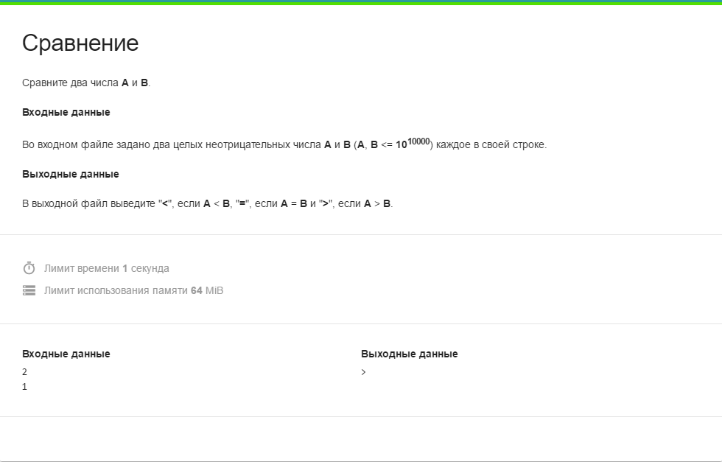

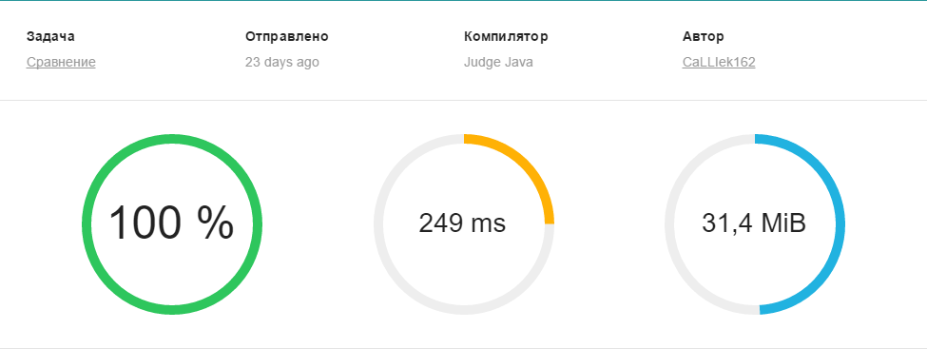

**import** java.io.Console;

**import** java.math.BigInteger;

**import** java.util.Scanner;

;

*/\*\**

*\**

*\* @author parsh*

*\*/*

**public** **class** Main {

*/\*\**

*\* @param args the command line arguments*

*\*/*

**public** **static** **void** main(String[] args) {

*//* ***TODO*** *code application logic here*

Scanner cin = **new** Scanner(System.in);

BigInteger a = cin.nextBigInteger();

BigInteger b = cin.nextBigInteger();

**if**(a.**compareTo**(b)==-1)

{

System.out.**print**('<');

**return**;

}

**if**(a.**compareTo**(b)==0)

{

System.out.**print**('=');

**return**;

}

**if**(a.**compareTo**(b)==1)

{

System.out.**print**('>');

}

}

}

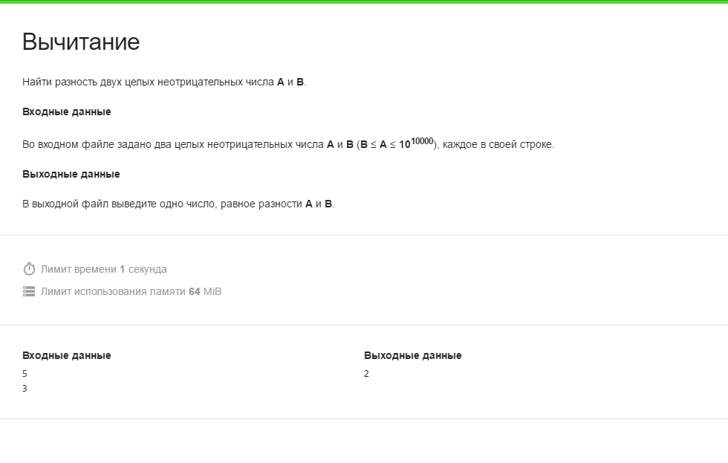

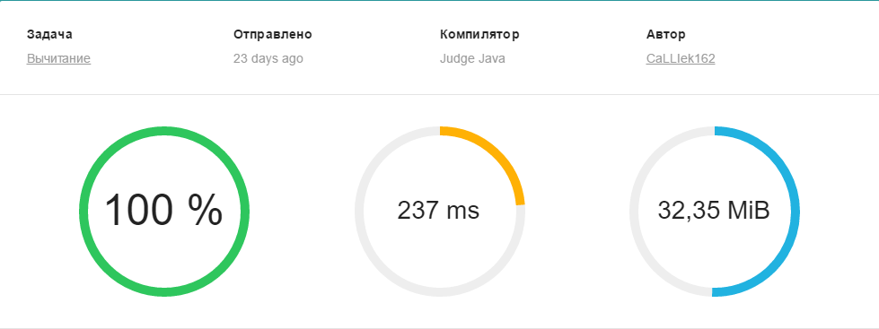

**import java.io.Console;**

**import java.math.BigInteger;**

**import java.util.Scanner;**

;

*/\*\**

*\* @author parsh*

*\*/*

**public** **class** **Main** {

**public** **static** **void** main(String[] args) {

*// TODO code application logic here*

Scanner cin = **new** Scanner(System.**in**);

BigInteger a = cin.nextBigInteger();

BigInteger b = cin.nextBigInteger();

BigInteger c ;

c = a.subtract(b);

System.out.print(c);

}

}

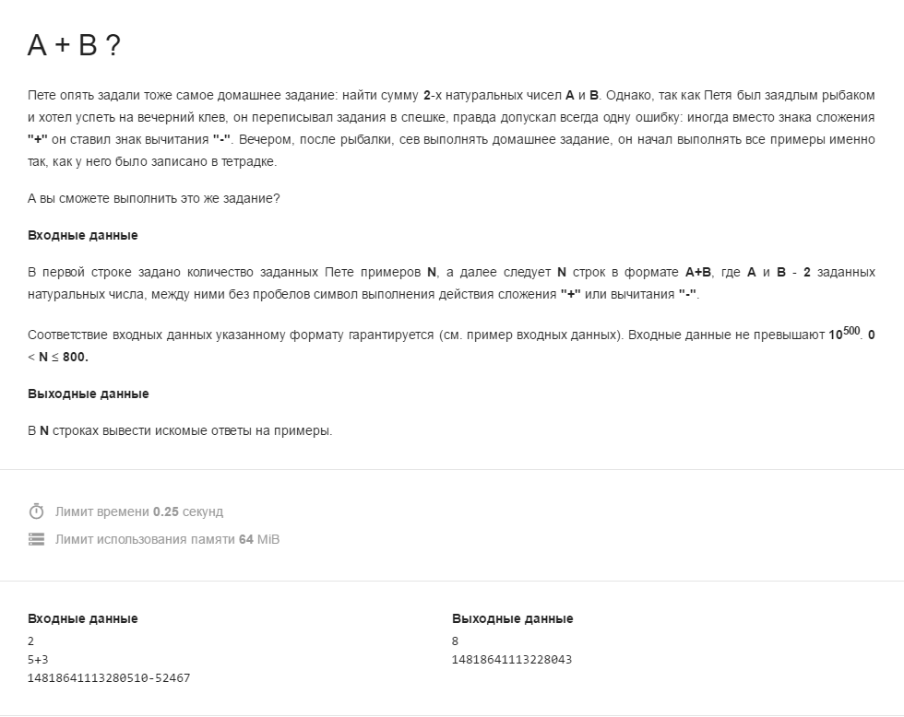

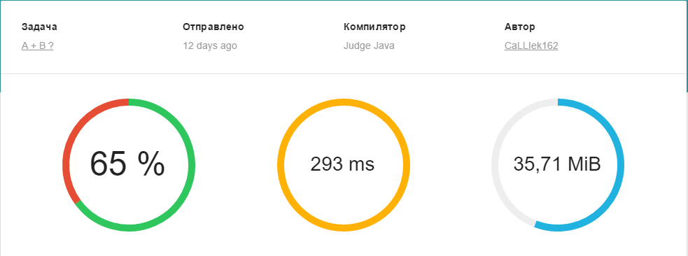

import java.math.BigInteger;

import java.util.Scanner;

*/\*\**

*\**

*\* @author student*

*\*/*

public class JavaApplication2 {

*/\*\**

*\* @param args the command line arguments*

*\*/*

public static void main(String[] args) {

*// TODO code application logic here*

Scanner cin = new Scanner(System.in);

int n = cin.nextInt();

**for**(int i=0; i<n; i++)

{

String c = cin.next();

int k = c.indexOf("+");

int k1 = c.indexOf("-");

String c1;

**if**(k1==-1)c1=c.substring(0, k);

**else**

c1=c.substring(0, k1);

BigInteger a = new BigInteger(c1);

String c2;

**if**(k1==-1)c2=c.substring(k+1, c.length());

**else**

c2=c.substring(k1+1, c.length());

BigInteger b = new BigInteger(c2);

**if**(k1==-1)

System.out.println(a.add(b));

**else**

System.out.println(a.subtract(b));

}

}

}

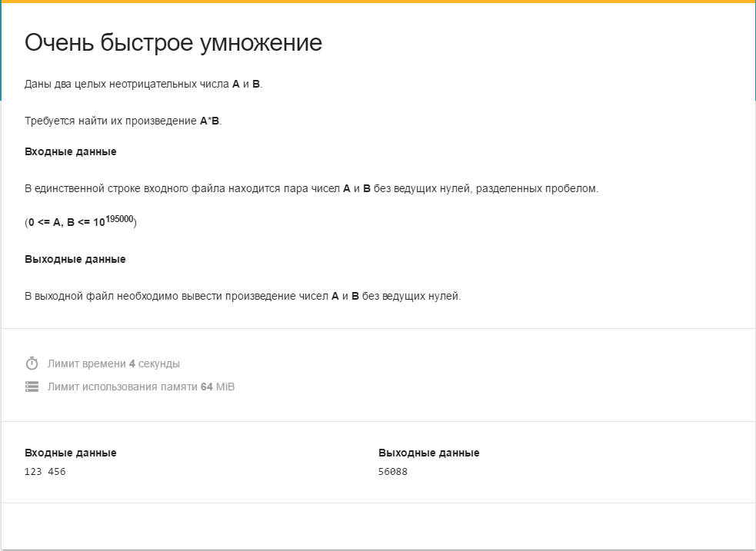

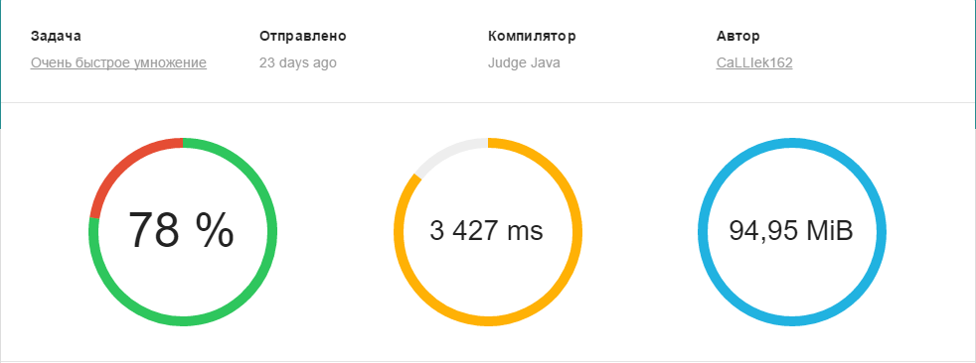

**import java.io.Console;**

**import java.math.BigInteger;**

**import java.util.Scanner;**

;

**public** **class** **Main** {

**public** **static** **void** main(String[] args) {

Scanner cin = **new** Scanner(System.**in**);

BigInteger a = cin.nextBigInteger();

BigInteger b = cin.nextBigInteger();

BigInteger c ;

c = a.multiply(b);

System.out.print(c);

}

}

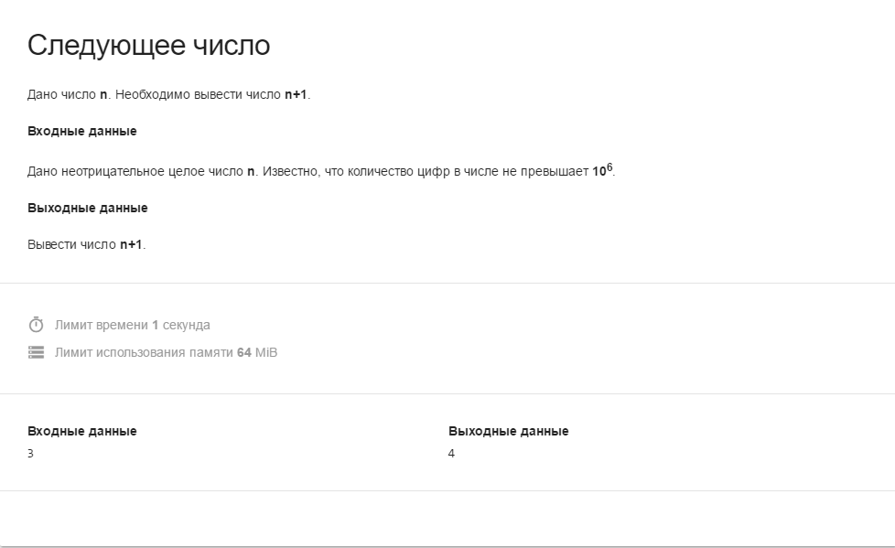

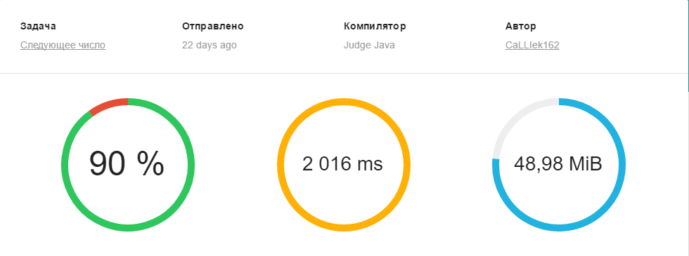

**import java.math.BigInteger;**

**import java.util.Scanner;**

;

**public** **class** **Main** {

**public** **static** **void** main(String[] args) {

*// TODO code application logic here*

Scanner cin = **new** Scanner(System.**in**);

BigInteger a = **new** BigInteger(cin.next());

BigInteger c = a.add(BigInteger.ONE);

System.out.print(c);

}

}

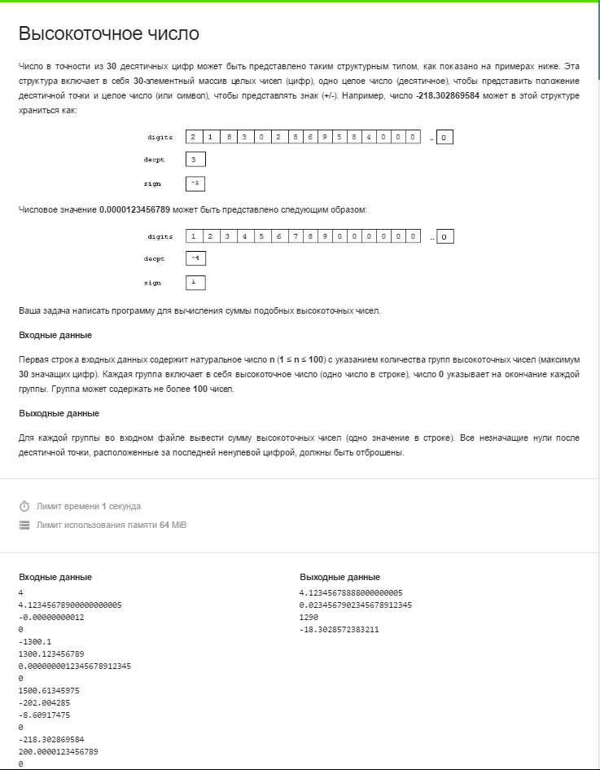

**import java.io.Console;**

**import java.math.BigDecimal;**

**import java.math.BigInteger;**

**import java.util.Scanner;**

;

*/\*\**

*\**

*\* @author parsh*

*\*/*

**public** **class** **Main** {

*/\*\**

*\* @param args the command line arguments*

*\*/*

**public** **static** **void** main(String[] args) {

*// TODO code application logic here*

Scanner cin = **new** Scanner(System.**in**);

BigDecimal a= **new** BigDecimal("0");

int n = cin.nextInt();

**while**(n!=0)

{

BigDecimal b = **new** BigDecimal(cin.next());

b=b.stripTrailingZeros();

a=a.add(b);

a=a.stripTrailingZeros();

**if**(b.compareTo(**new** BigDecimal("0"))==0)

{

n--;

System.out.println(a.toPlainString());

a = BigDecimal.ZERO;

}

}

}

}